EXPERIMENT- 1

CONCEPT DESIGN WITH E-R MODEL

AIM: To Relate the entities appropriately. Apply cardinalities for each relationship. Identify strong and weak entities. Indicate the type of relationships (total/partial). Incorporate generalization, aggregation and specialization etc wherever required.

E-R Model

Bus
- BusNo
- Source
- Destination
- CoachType

SCHEMA

Bus: Bus(BusNo :String ,Source : String, Destination: String, Coach Type: String)

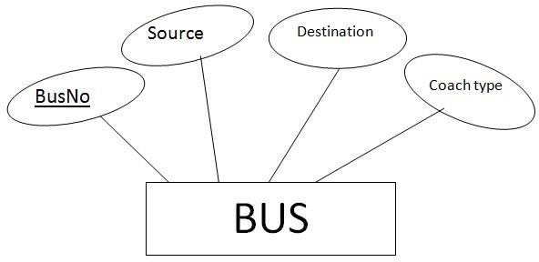

Ticket
- TicketNo
- DOJ
- Address
- ContactNo
- BusNo
- SeatNo
- Source
- Destination

SCHEMA

Ticket (TicketNo: string, DOJ: date, Address: string, ContactNo : string, BusNo:String SeatNo : Integer, Source: String, Destination: String)

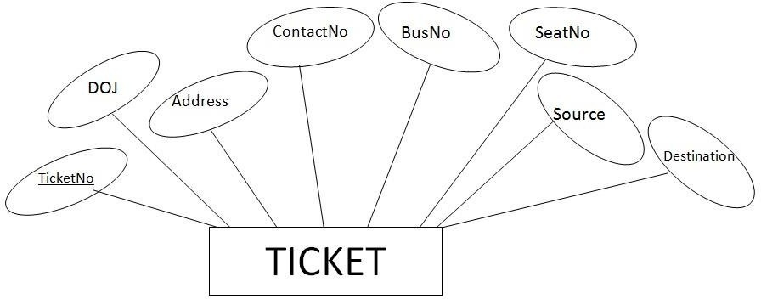

Passenger
  - PassportID
  - TicketNo
  - Name
  - ContactNo
  - Age
  - Sex
  - Address

SCHEMA

Passenger (PassportID: String, TicketNo :string, Name: String, ContactNo: string, Age: integer, Sex: character, Address: String)

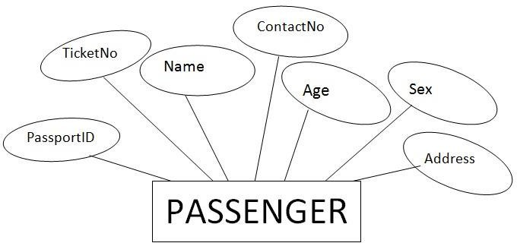

Reservation
  - PNRNo
  - DOJ
  - No_of_seats
  - Address
  - ContactNo
  - BusNo
  - SeatNo

SCHEMA
Reservation(PNRNo: String, DOJ: Date, NoofSeats: integer , Address: String ,ContactNo: String, , BusNo: String,SeatNo:Integer)

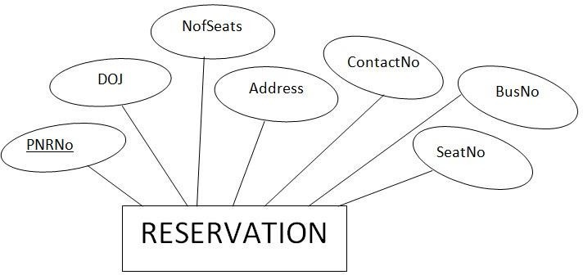

Cancellation
    - PNRNo
    - DOJ
    - SeatNo
    - ContactNo
    - Status

SCHEMA

Cancellation (PNRNo: String, DOJ: Date, SeatNo: integer, ContactNo: String, Status: String)

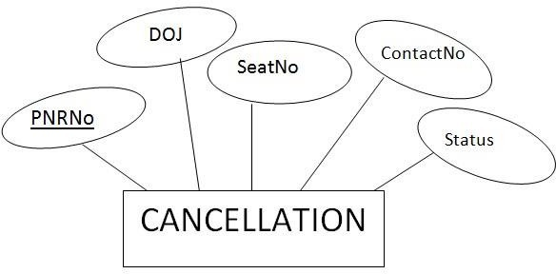

CONCEPT DESIGN WITH E-R MODEL

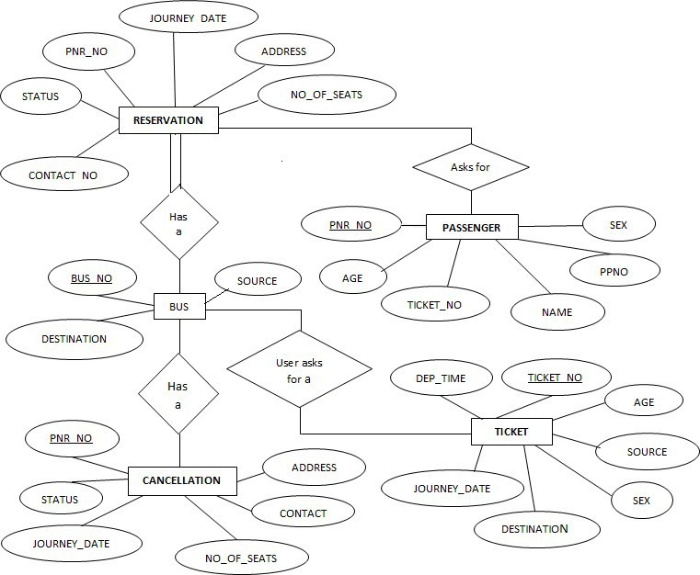

EXPERIMENT – 2 RELATIONAL MODEL

AIM: To Represent all the entities (Strong, Weak) in tabular fashion. Represent relationships in a tabular fashion.

- Bus: Bus(BusNo: String, Source: String, Destination: String, CoachType: String)

ColumnName | Datatype | Constraints | Type of Attributes
BusNo | Varchar(10) | Primary key | Single-value
Source | Varchar(20) |  | Single-value
Destination | Varchar(20) |  | Simple
CoachType | Varchar(10) |  | Simple
Mysql>create table Bus(BusNo varchar(10),source varchar(20),Destination varchar(20),coachType varchar(10),primary key(BusNo));

Mysql>desc Bus;
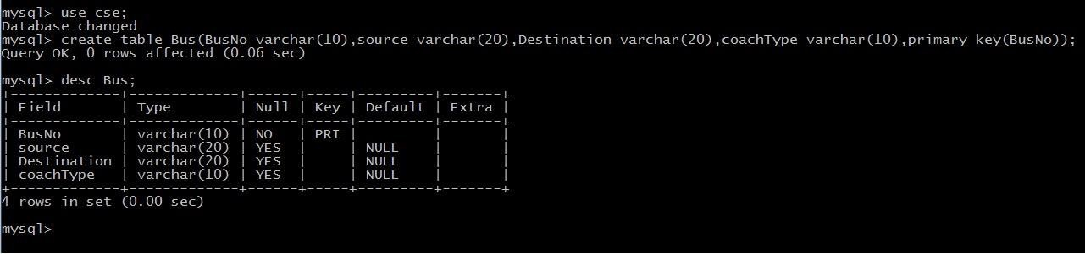

Ticket:

Ticket(TicketNo: string, DOJ: date, Address:string,ContactNo: string, BusNo:String, SeatNo :Integer, Source: String, Destination: String)
ColumnName | Datatype | Constraints | Type of Attributes
TicketNo | Varchar(20) | Primary Key | Single-valued
DOJ | Date |  | Single-valued
Address | Varchar(20) |  | Composite
ContactNo | Integer |  | Multi-valued
BusNo | Varchar(10) | Foreign Key | Single-valued
SeatNo | Integer |  | Simple
Source | Varchar(10) |  | Simple
Destination | Varchar(10) |  | Simple

Mysql> create table ticket(ticketno varchar(20), doj date,address varchar(20),contactno int, busno varchar(20),seatno int,source varchar(10),destination varchar(10),primary key(ticketno,busno) foreign key(busno) references bus(busno);

Mysql>desc Ticket;
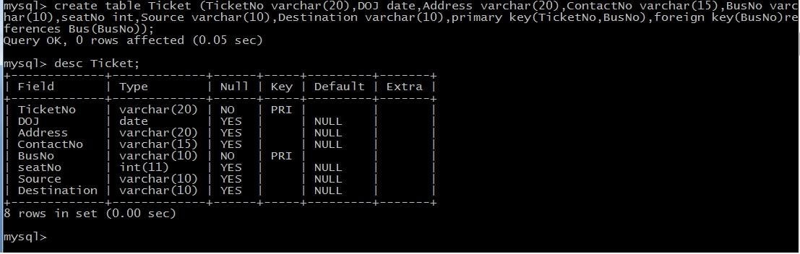

Passenger:

Passenger(PassportID: String, TicketNo:string,Name: String, ContactNo:string,Age: integer, Sex: character, Address: String);

ColumnName | Datatype | Constraints | Type of Attributes
PassportID | Varchar(15) | Primary Key | Single-valued
TicketNo | Varchar(20) | Foreign Key | Single-valued

Name | Varchar(20) |  | Composite
ContactNo | Varchar(20) |  | Multi-valued
Age | Integer |  | Single-valued
Sex | character |  | Simple
Address | Varchar(20) |  | Composite

Mysql> Create table passenger(passportID varchar(15) ,TicketNo varchar(15),Name varchar(15),ContactNo varchar(20),Age integer, sex char(2),address varchar(20), primary key(passportID,TicketNo),foreign key(TicketNo) references Ticket(TicketNo));
Mysql> desc passenger;

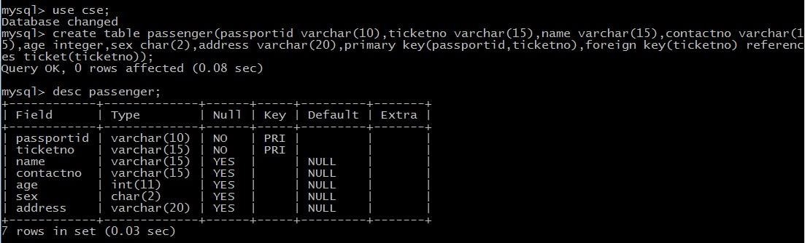

Reservation:

Reservation(PNRNo: String, DOJ: Date, NoofSeats: integer , Address: String ,ContactNo: String, , BusNo: String,SeatNo:Integer)

ColumnName | Datatype | Constraints | Type of Attributes
PNRNo | Varchar(20) | Primary Key | Single-valued
DOJ | date |  | Single-valued
No_of_Seats | Integer |  | Simple
Address | Varchar(20) |  | Composite
ContactNo | Varchar(10) |  | Multi-valued

BusNo | Varchar(10) | Foreign Key | Single-valued
SeatNo | Integer |  | Simple
Mysql> Create table Resevation(PNRNo varchar(20),DOJ date,NoofSeates integer,Address varchar(20),ContactNo varchar(20),BusNo varchar(20),SeatNo integer, primary key(PNRNo,BusNo),foreign key(BusNo) references Bus(BusNo));

Mysql> desc reservation;
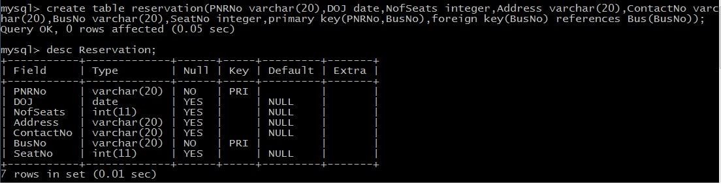

Cancellation:

Cancellation (PNRNo: String,DOJ: Date, SeatNo: integer,ContactNo: String,Status: String)

ColumnName | Datatype | Constraints | Type of Attributes
PNRNo | Varchar(10) | Primary Key | Single-valued
DOJ | date |  | Single-valued
SeatNo | Integer |  | Simple
ContactNo | Varchar(15) |  | Multi-valued
Status | Varchar(10) |  | Simple

Mysql> create table cancellation(PNRNo varchar(10),DOJ date,SeatNo integer, ContactNo varchar(15),Status varchar(10), primary key(PNRNo), foreign key(PNRNo) references reservation(PNRNo));

Mysql> desc cancellation;

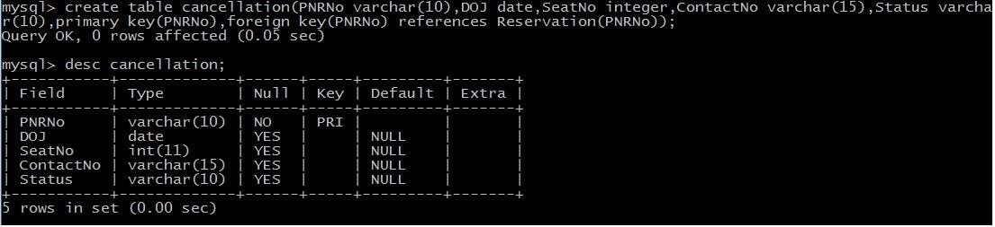

EXPERIMENT – 3 NORMALIZATION

AIM: Apply the database Normalization techniques for designing relational database tables to minimize duplication of information like 1NF, 2NF, 3NF, BCNF.

Normalization is a process of converting a relation to be standard form by decomposition a larger relation into smaller efficient relation that depicts a good database design.

- 1NF: A Relation scheme is said to be in 1NF if the attribute values in the relation are atomic.i.e., Mutli –valued attributes are not permitted.

- 2NF: A Relation scheme is said to be in 2NF,iff and every Non-key attribute is fully functionally dependent on primary Key.

- 3NF: A Relation scheme is said to be in 3NF,iff and does not have transitivity dependencies. A Relation is said to be 3NF if every determinant is a key for each & every functional dependency.

- BCNF: A Relation scheme is said to be BCNF if the following statements are true for eacg FD P->Q in set F of FDs that holds for each FD. P->Q in set F of FD’s that holds over R. Here P is the subset of attributes of R & Q is a single attribute of R.

The given FD is a trival

P is a super key.

Normalized tables are:-

Mysql> create table Bus2(BusNo varchar(20) primary key,Source varchar(20),Destination varchar(20));

Mysql>Create table passenger4(PPN varchar(15) Primary key,Name varchar(20),Age integer,Sex char,Address varchar(20));

Mysql> Create table PassengerTicket(PPN varchar(15) Primary key,TicketNo integer);

Mysql> Create table Reservation2(PNRNO integer Primary key, JourneyDate DateTime,NoofSeats int,Address varchar(20),ContactNo Integer);

Mysql> create table Cancellation2(PNRNO Integer primary key,JourneyDate DateTime,NoofSeats Integer,Address varchar(20),ContactNo Integer,foreign key(PNRNO) references Reservation2(PNRNO));

Mysql> Create table Ticket2(TicketNo Integer Primary key,JourneyDate DateTime, Age Int(4),Sex char(2),Source varchar(20),Destination varchar(20),DeptTime varchar(2));

EXPERIMENT – 4 PRACTICING DDL COMMANDS

AIM : Creating Tables and altering the Tables

Mysql>Create table passenger2(passportId Integer Primary Key,Name varchar(10) Not Null,Age Integer Not Null,Sex char,Address varchar(20) Not Null);

Mysql> desc passenger2;
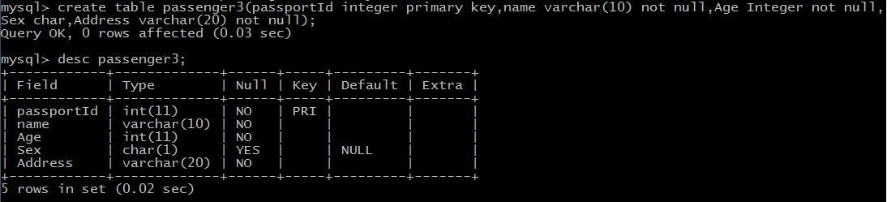
USING ALTER COMMAND

Adding Extra column to Existing Table

Mysql>Alter table passenger3 add column TicketNo varchar(10);
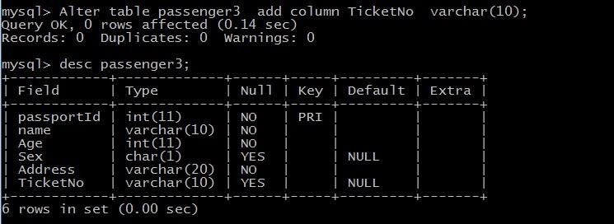
Mysql>Alter Table passenger3 add Foreign key(TicketNo) references Ticket(TicketNo);
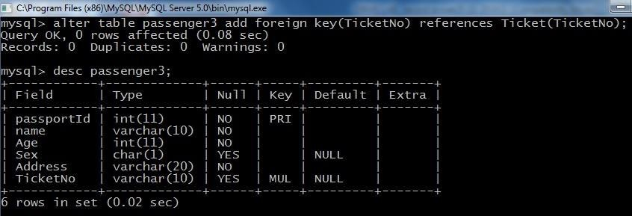
Mysql>Alter Table passenger3 Modify column Name varchar(20);
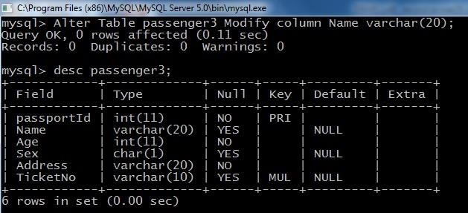
Mysql>Alter table passenger drop foreign key fk1;
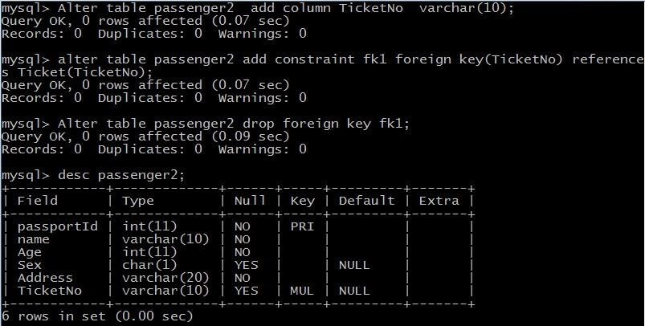
Mysql> Alter table passenger2 Drop column TicketNo;
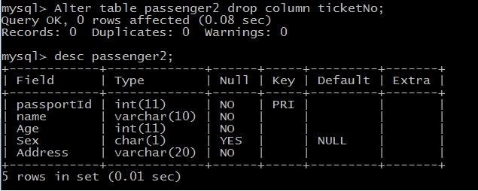

EXPERIMENT – 5 PRACTICING DML COMMANDS

AIM: Create a DML Commands are used to manage data within the scheme objects.

DML Commands:

INSERT COMMAND ON BUS2 & PASSENGER2 RELATIONS

mysql> select * from Bus2; Empty set (0.00 sec)

mysql> insert into Bus2 values(1234,'Hyderabad','Tirupathi'); Query OK, 1 row affected (0.03 sec)
mysql> insert into Bus2 values(2345,'Hyderabad','Banglore'); Query OK, 1 row affected (0.01 sec)
mysql> insert into Bus2 values(23,'Hyderabad','Kolkata'); Query OK, 1 row affected (0.03 sec)
mysql> insert into Bus2 values(45,'Tirupathi','Banglore'); Query OK, 1 row affected (0.03 sec)
mysql> insert into Bus2 values(34,'Hyderabad','Chennai'); Query OK, 1 row affected (0.03 sec)

mysql> select * from Bus2;
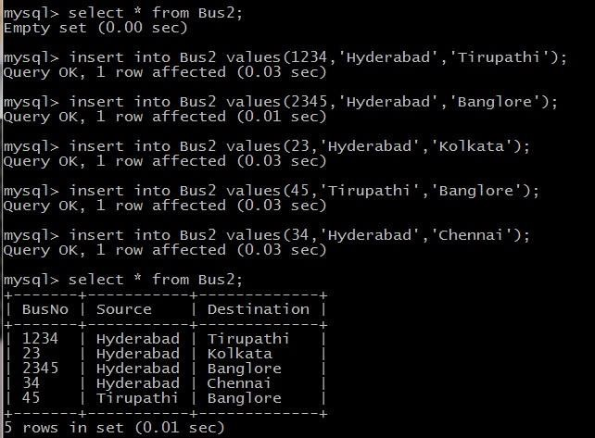
mysql> select * from Passenger2; Empty set (0.00 sec)
mysql> insert into Passenger2 values(145,'Ramesh',45,'M','abc123'); Query OK, 1 row affected (0.05 sec)
mysql> insert into Passenger2 values(278,'Geetha',36,'F','abc124'); Query OK, 1 row affected (0.02 sec)
mysql> insert into Passenger2 values(4590,'Ram',30,'M','abc12'); Query OK, 1 row affected (0.03 sec)
mysql> insert into Passenger2 values(6789,'Ravi',50,'M','abc14'); Query OK, 1 row affected (0.03 sec)
mysql> insert into Passenger2 values(5622,'Seetha',32,'F','abc55'); Query OK, 1 row affected (0.03 sec)

mysql> select * from Passenger2;
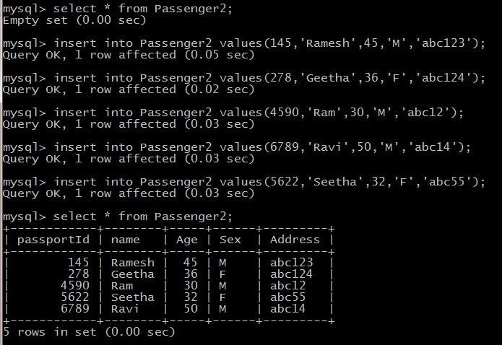
UPDATE COMMAND ON BUS2 RELATION

UPDATE Selected Rows & Multiple Rows

mysql> Update Bus2 SET Source='Secundrabad' where BusNo=1234; Query OK, 1 row affected (0.05 sec) Rows matched: 1 Changed: 1 Warnings: 0
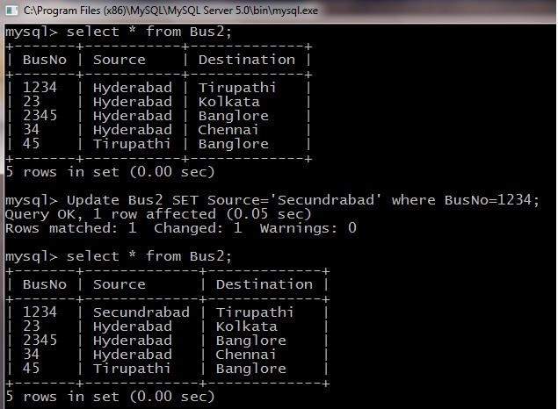

DELETE COMMAND ON BUS2 RELATION

DELETES Selected Rows and Multiple Rows

mysql> Delete from Bus2 where BusNo=1234; Query OK, 1 row affected (0.05 sec) mysql> select * from Bus2;
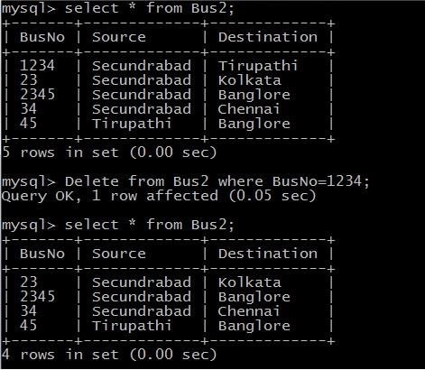
mysql> Delete from Bus2 where Source=’Secundrabad’; Query OK, 1 row affected (0.05 sec) mysql> select * from Bus2;
